**INNOVATE. CREATE. SOLVE**

Bangalore, Karnataka, India

 AN

INTERNSHIP REPORT

ON

**“**Website review for Sri Maruthi Pharma**”**

**Bachelor of Engineering**

**In**

**Computer Science and Engineering**

**Submitted by: Athishay Jain(4SU18CS013)**



**SDM Institute of Technology, Ujire 574240**

**ABOUT THE COMPANY**

**IC Solution (ICS)** is a digital service provider that aims to provide software, designing and marketing solutions to individuals and businesses. At **ICS**, we believe that service and quality is the key to success.

We provide all kinds of technological and designing solutions from Billing Software to Web Designs or any custom demand that you may have. Experience the service like none other!

**Some of our services include:**

**Development** - We develop responsive, functional and super-fast websites.

We keep User Experience in mind while creating websites. A website should load quickly and should be accessible even on a small view-port and slow internet connection.

**Mobile Application** - We offer a wide range of professional Android, iOS & Hybrid app development services for our global clients, from a start up to a large enterprise.

**Design** - We offer professional Graphic design, Brochure design & Logo design. We are experts in crafting visual content to convey the right message to the customers.

**Consultancy** - We are here to provide you with expert advice on your design and development requirement.

**Videos** - We create a polished professional video that impresses your audience.

**TABLE OF CONTENTS**

**--------------------------------------------------------------------------------------------------------------------**

**Table of contents: i**

**--------------------------------------------------------------------------------------------------------------------**

Overview of the Project 1

About Sri Maruthi Pharma 2

SMP or Sri Maruthi Pharma are dealers in 3

Tools Used 4

Implementation 5

Snapshots 6

Bibliography 8

--------------------------------------------------------------------------------------------------------------------

**Overview of the Project**

**Project Name:** “Website review for Sri Maruthi Pharma”

**Team Members:** Mamber1: Rahul HD

Member2: Darshan SB

Member3: Aryan C mallik

Member4: Athishay jain

This project is based on Web Development And its Applications. The main objective of this project is to learn the implementation of HTML, CSS and JavaScript. The basic webpage of this project is created using HTML and styling of the webpage is done using CSS.

This page is about the latest helpful automobiles called “Electric vehicles”.

**About**  **Sri Maruthi Pharma**

Sri Maruthi Pharma in Bangalore is one of the leading businesses in Surgical Equipment Dealers. Also known for Surgical Equipment Dealers, Pharmaceutical Product Distributors, Medical Equipment Dealers, Pharmaceutical Distributors, Surgical Item Dealers, Medicine Distributors, Medical Product Dealers, Generic Medicine Wholesalers and much more.

SMP or Sri Maruthi Pharma are dealers in:

Chemists

Surgical Equipment Dealers

Pharmaceutical Product Distributors

Medical Equipment Dealers

Pharmaceutical Distributors

Pharmaceutical Product Manufacturers

Medicine Wholesalers

Surgical Face Mask Dealers

N95 Face Mask Dealers

Medicine Distributors

Generic Medicine Distributors

Pharmaceutical Product Wholesalers and much more

**TOOLS USED**

**Software Requirements:**

⦁ Visual Studio Code 2019.

⦁ Google Chrome or Microsoft Edge of latest version.

⦁ Front End: HTML, CSS.

⦁ Linux 7.1 or Windows XP/7/8/10 OS or Mac OS.

**Hardware Requirements:**

* Processor: Intel i5 Core Processor
* Clock speed: 2.20GHz
* Monitor: 1080p Resolution
* RAM: 8GB

**IMPLEMENTATION**

**Source Code:- (p1.css)**

*{

margin: 0px;

padding:0px;

box-sizing: border-box;

}

body{

font-size: 20px;

overflow-y: hidden ;

font-family:'Times New Roman', Times, serif;

}

header{

background-image: linear-gradient(rgba(0,0,0,0.7),rgba(0,0,0,0.5)),url('images/bg.jpg');

background-size: cover;

background-repeat:no-repeat ;

background-position: center;

height:100vh;

}

.row{

max-width: 1180px;

margin: 0 auto;

}

.logo{

height: 120px;

width: auto;

float: left;

margin-top: 20px;

border-color: cornflowerblue;

}

.main-nav{

float: right;

margin-top: 60px;

}

.main-nav li{

display: inline;

list-style: none;

margin-left: 40px;

}

.main-nav li a{

padding:5px 0px;

color: brown;

text-decoration: none;

text-transform: uppercase;

font-size: 95%;

font-weight: 100;

}

.main-nav li a:hover{

border-bottom: 2px solid black;

background-color:black;

}

.main-content-header{

width: 1180px;

position: absolute;

/* border: 1px solid red; */

top:50%;

left: 50%;

transform:translate(-50%,-50%);

}

h1{

color:white;

font-size: 250%;

word-spacing: 4px;

letter-spacing: 3px;

margin-bottom: 20px;

text-transform: uppercase;

font-weight: lighter;

text-align: center;

}

h2{

text-align: center;

color: cornsilk ;

}

.lead{

color: blanchedalmond;

}

p{

margin:0;

padding: 0 10rem;

font-family:serif;

font-size: 1.2rem;

word-spacing: 3px;

color:thistle;

}

.mydiv

{

border: 5px outset lime;

background-color:lightblue;

text-align:center;

}

.colorchange{

animation: colorchangehunger 1s infinite;

}

@keyframes colorchangehunger{

0%{color: red;}

25%{color: green;}

50%{color: white;}

100%{color: rgb(17, 2, 31);}

}

/* <WHATSAPP> */

#myBtn {

display: none;

position: fixed;

bottom: 20px;

right: 30px;

z-index: 99;

font-size: 18px;

border: none;

outline: none;

background-color: red;

color: white;

cursor: pointer;

padding: 15px;

border-radius: 4px;

}

#myBtn:hover {

background-color: #555;

}

/* .ab{

background-color:whitesmoke;

} */

.tab{

float: right;

margin-top: 30px

}

.tab li{

display: inline;

list-style: none;

margin-left: 40px;

}

.tab li a{

padding:5px 0px;

color: brown;

text-decoration: none;

text-transform: uppercase;

font-size: 95%;

font-weight: 100;

}

.about

{

font-size:20px;

color:white;

}

.container{

margin: 5px;

color:white;

padding: 0 5rem;

font-size:15px;

}

p

{

color:5px;

padding:5px

font-size:10px;

}

h2:hover{

color: hsl(0, 89%, 25%);

}

h2{

text-align: center;

/* border-inline: black; */

}

h3{

text-align:center;

font-family: serif;

font-size: 30px;

color:hsl(0, 89%, 25%);

}

/* <TESTIMONY> */

.avatar {

border: 2px solid black;

background-color:wheat;

border-radius: 5px;

padding: 16px;

margin: 16px 0;

}

.avatar::after {

content: "";

clear: both;

display: table;

}

.avatar img {

float: left;

margin-right: 20px;

border-radius: 50%;

}

.avatar span {

font-size: 20px;

margin-right: 15px;

}

@media (max-width: 500px) {

.avatar {

text-align: center;

}

.avatar img {

margin: auto;

float: none;

display: block;

}

}

p{

color:lavender;

}

h3{

text-align: center;

}

.containe {

padding: 15px;

background-color: white;

}

/* Full-width input fields */

input[type=text] {

width: 100%;

padding: 15px;

margin: 5px 0 22px 0;

display: inline-block;

border: none;

background: #f1f1f1;

}

/* input[type=tel]:focus {

background-color: #ddd;

outline: none;

} */

input[type=tel] {

width: 100%;

padding: 15px;

margin: 5px 0 22px 0;

display: inline-block;

border: none;

background: #f1f1f1;

}

input[type=email] {

width: 100%;

padding: 15px;

margin: 5px 0 22px 0;

display: inline-block;

border: none;

background: #f1f1f1;

}

input[type=text]:focus, input[type=password]:focus {

background-color: #ddd;

outline: none;

}

.pg {

width: 100%;

padding: 15px;

margin: 5px 0 22px 0;

display: inline-block;

border: none;

background: #f1f1f1;

}

/* Overwrite default styles of hr */

hr {

border: 1px solid #f1f1f1;

margin-bottom: 25px;

}

/* Set a style for the submit button */

.registerbtn {

background-color: #04AA6D;

color: white;

padding: 16px 20px;

margin: 8px 0;

border: none;

cursor: pointer;

width: 100%;

opacity: 0.9;

}

.registerbtn:hover {

opacity: 1;

}

body,

html {

overflow-x: hidden;

}

/* body {

margin: 0;

width: 100%;

font-family: "Oswald", sans-serif;

font-size: 12pt;

font-weight: 400;

} */

h1,

h2,

h3,

h4,

h5,

h6 {

font-family: 'Times New Roman', Times, serif;

}

a {

text-decoration: none;

transition: all 0.5s ease-in-out;

}

a:hover {

transition: all 0.5s ease-in-out;

}

.footer-block {

width: 100%;

height: auto;

display: flex;

flex-direction: column;

flex-wrap: nowrap;

align-items: center;

justify-content: space-around;

background: linear-gradient(to right, #0c4c91, #404140);

background-size: 400% 400%;

animation: footerblock 6s ease infinite;

z-index: 998;

}

@keyframes footerblock {

0% {

background-position: 0 50%;

}

50% {

background-position: 100% 50%;

}

100% {

background-position: 0 50%;

}

}

#footer-logo {

width: 100%;

height: auto;

display: flex;

flex-direction: column;

align-items: center;

justify-content: center;

flex-wrap: nowrap;

padding: 40px 0px 40px 0px;

margin-top: 60px;

background: linear-gradient(

to right,

rgba(255, 255, 255, 0.5) 0,

rgba(12, 76, 145, 0.5) 50%,

rgba(255, 255, 255, 0.5) 100%

);

background-size: 400% 400%;

box-shadow: rgb(38 57 77) 0px 20px 30px -10px;

border: 1px solid rgba(255, 255, 255, 0.2);

animation: footerlogo 15s ease-in-out infinite;

}

@keyframes footerlogo {

0% {

background-position: -50% 50%;

}

50% {

background-position: 150% 50%;

}

100% {

background-position: -50% 50%;

}

}

#footer-logo img {

padding-left: 10px;

padding-right: 10px;

}

#socials-bar {

background: #404140;

width: 100%;

height: auto;

display: flex;

flex-direction: row;

flex-wrap: nowrap;

align-items: center;

justify-content: space-evenly;

padding: 30px 0px 30px 0px;

}

#socials-bar a {

color: white;

font-size: 40pt;

}

@media screen and (max-width: 620px) {

#socials-bar a {

font-size: 30pt;

}

}

#socials-bar a:hover {

text-shadow: 0px 0px 10px #222, 0px 0px 20px #000;

transform: translateY(10px) scale(1.2);

}

#footer-menu {

display: flex;

flex-direction: row;

flex-wrap: wrap;

justify-content: space-around;

align-items: center;

width: 100%;

height: 200px;

margin: 30px 10px 30px 10px;

}

@media screen and (max-width: 600px) {

#footer-menu {

height: 360px;

}

}

@media screen and (max-width: 360px) {

#footer-menu {

height: 560px;

}

}

#footer-menu a {

color: white;

font-size: 16pt;

display: flex;

flex-direction: row;

width: 12%;

align-items: center;

justify-content: center;

}

@media screen and (max-width: 1620px) {

#footer-menu a {

width: 20%;

}

}

@media screen and (max-width: 1100px) {

#footer-menu a {

width: 30%;

padding: 10px 0px 10px 0px;

}

}

@media screen and (max-width: 600px) {

#footer-menu a {

width: 50%;

}

}

@media screen and (max-width: 360px) {

#footer-menu a {

width: 100%;

padding: 12px 0px 12px 0px;

}

}

#footer-menu a:hover {

transform: translateY(10px) scale(1.2);

color: #aaa;

}

#footer-contact {

display: flex;

flex-direction: column;

flex-wrap: nowrap;

align-items: center;

justify-content: center;

width: 34%;

height: 270px;

background: rgba(255, 255, 255, 0.25);

box-shadow: rgb(0 0 0 / 25%) 0px 54px 55px, rgb(0 0 0 / 22%) 0px -12px 30px,

rgb(0 0 0 / 22%) 0px 4px 6px, rgb(0 0 0 / 27%) 0px 12px 13px,

rgb(0 0 0 / 19%) 0px -3px 5px;

border-radius: 12px;

border: 1px solid rgba(255, 255, 255, 0.2);

}

@media screen and (max-width: 1300px) {

#footer-contact {

width: 70%;

}

}

@media screen and (max-width: 930px) {

#footer-contact {

width: 90%;

}

}

@media screen and (max-width: 674px) {

#footer-contact {

justify-content: space-around;

height: 850px;

padding: 30px 0px 30px 0px;

}

}

.contact-info {

display: flex;

width: 100%;

height: 300px;

flex-direction: row;

flex-wrap: nowrap;

align-items: center;

justify-content: space-between;

position: relative;

bottom: 25px;

}

@media screen and (max-width: 674px) {

.contact-info {

flex-direction: column;

height: 70%;

justify-content: space-around;

bottom: 0px;

}

}

#contact-top {

margin-left: 10%;

}

@media screen and (min-width: 1300px) and (max-width: 1520px) {

#contact-top {

margin-left: 4%;

}

}

@media screen and (max-width: 674px) {

#contact-top {

margin-left: 0 !important;

}

}

#contact-bottom {

margin-right: 20%;

}

@media screen and (min-width: 1300px) and (max-width: 1520px) {

#contact-bottom {

margin-right: 8%;

}

}

@media screen and (max-width: 674px) {

#contact-bottom {

margin-right: 0 !important;

}

}

#contact-top,

#contact-bottom {

display: flex;

flex-direction: column;

align-items: flex-start;

justify-content: space-between;

height: 230px;

}

@media screen and (max-width: 674px) {

#contact-top,

#contact-bottom {

align-items: center;

height: auto;

}

}

#contact-buttons {

position: relative;

bottom: 40px;

display: flex;

flex-direction: row;

justify-content: space-between;

width: 80%;

height: auto;

align-items: center;

}

@media screen and (min-width: 1300px) and (max-width: 1520px) {

#contact-buttons {

width: 92%;

}

}

@media screen and (max-width: 674px) {

#contact-buttons {

width: 90%;

flex-direction: column;

justify-content: space-around;

height: 30%;

bottom: 0px;

}

}

#contact-buttons a {

background: rgba(100, 100, 100, 0.35);

box-shadow: rgba(0, 0, 0, 0.4) 0px 2px 4px, rgba(0, 0, 0, 0.3) 0px 7px 13px -3px, rgba(0, 0, 0, 0.2) 0px -3px 0px inset;

border-radius: 10px;

border: 1px solid rgba(255, 255, 255, 0.2);

color: white;

font-size: 12pt;

width: 200px;

display: flex;

flex-direction: row;

align-items: center;

justify-content: center;

padding: 15px 0px 15px 0px;

}

@media screen and (max-width: 674px) {

#contact-buttons a {

width: 220px;

}

}

#contact-buttons a:hover {

background: #0c4c91;

transform: translateY(10px);

box-shadow: rgba(0, 0, 0, 0.56) 0px 22px 70px 4px;

}

#contact-buttons i {

font-size: 16pt;

padding: 10px;

}

#footer-partners {

display: flex;

flex-direction: row;

width: 40%;

align-items: center;

justify-content:space-evenly;

height: 100px;

margin-top: 30px;

}

#footer-partners p {

color: white;

font-size: 15pt;

}

.icon{

align-items: center;

}

#x97gk87d {

position: absolute;

left:0;

top: 50%;

opacity: 0.0001;

font-size: 5pt;

}

.k8d37b6db4 {

color: #0c4c91;

}

.cp-text{

color: rgba(0,0,0,.7);

text-shadow: 0 1px rgba(255, 255, 255, 0.1);

text-align: center;

padding:5%;

}

.jsc{

height:100%;

margin:auto;

width:960px;

overflow:hidden;

}

**SNAPSHOTS**

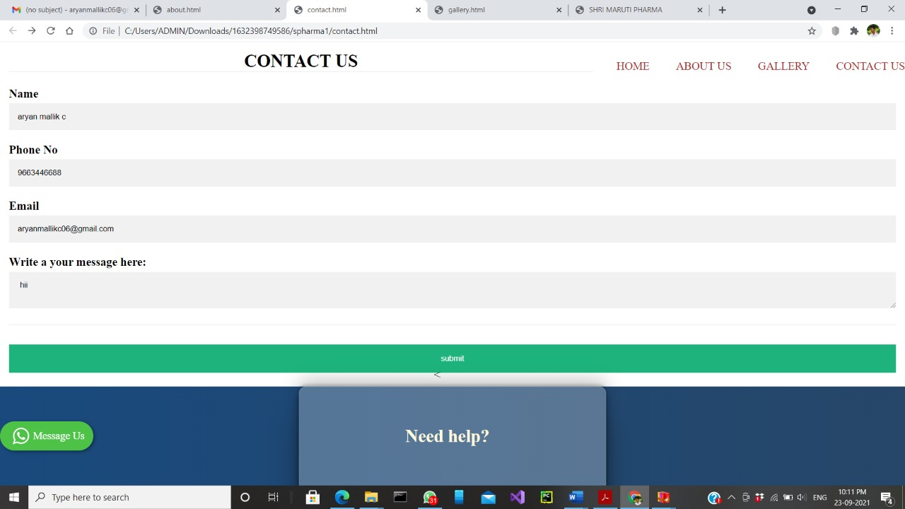

**1.Create account**

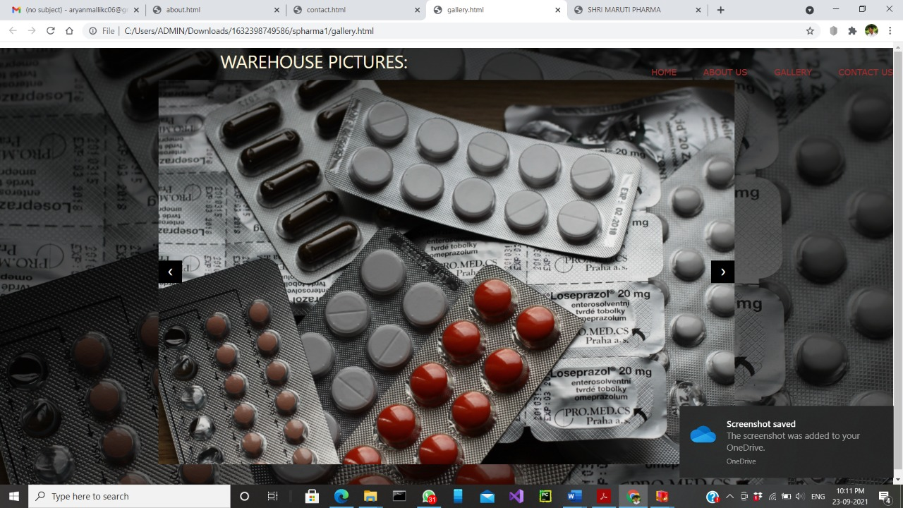

**2.Home page**

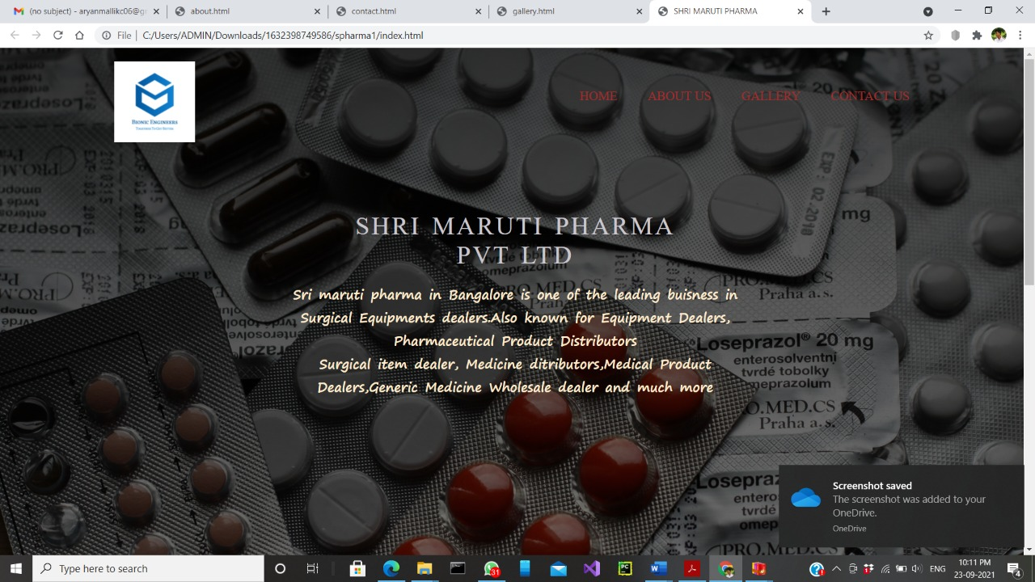

**3.informagtion page**

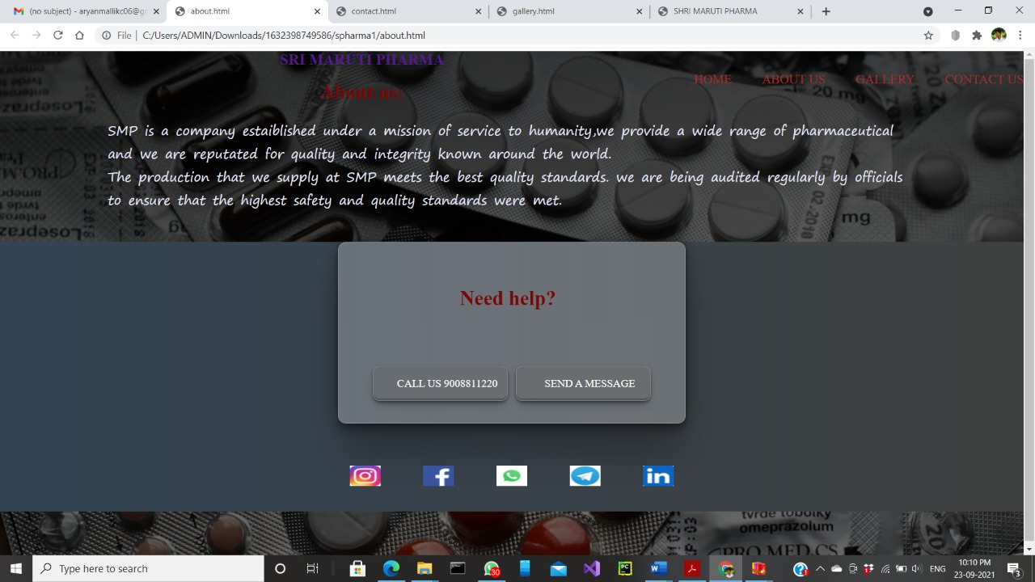

**4.Asking question page**

**BIBLIOGRAPHY**

For more information

* https://www.justdial.com/Bangalore/Sri-Maruti-Pharma-Near-Rayon-Circle-Chamarajpet/080PXX80-XX80-120605040354-W1F1_BZDET
* https://en.wikipedia.org/wiki/Review_site